<<Words highlighted show the actual style name. When you click on “styles” you can select these style tags and it will format your text correctly.>> Also see paper checklist at bottom of this file.
Article Title <<Paper Title>>
Byline (By Author’s Name, Title (PE, PhD, etc.), and NAFE Member Number<<Byline>>

Abstract<<Subhead>>
Replace with abstract text. Your abstract should give readers a brief summary of your article. It should concisely describe the contents of your article and include key terms. It should be informative, accessible and not only indicate the general scope of the article but also state the main results obtained and conclusions drawn. The abstract should be complete in itself; it should not contain undefined abbreviations and no table numbers, figure numbers, references or equations should be referred to. It should be suitable for direct inclusion in abstracting services and should not be more than 150 words. The abstract should only include information in the paper, and should not include any information not in the paper. The thesis needs to be clear and be the unifying concept the paper centers on. The more it does not address the thesis, the more likely it is tangential and may need to be redirected.

In this example, it is a case study of the work of one set of engineers, so the thesis is “it wasn’t done properly” and the paper goes into detail of why so, why these errors are significant, and what should have been done differently by showing the other team’s work. The conclusion is “this original work was not done appropriately because they didn’t apply the right theory or procedures”. The overall significance (broadening statement) is that this pattern of thought (applying a design code without accounting for the assumptions and design margins as well as not checking your computer models) can be extended to other investigations.

[INTRO]Engineering codes are a key method to guide designs to safe and reliable outcomes. Many such codes have prescribed calculations where the user is guided to provide specific inputs in a series of calculations, often using charts or tables, to get specific outputs. The design margins, units, and underlying theory are not always apparent. Engineering codes may not be suitable for reverse engineering an incident. [THESIS] This article examines a criminal negligence case in which an initial forensic analysis incorrectly applied the ASME Pressure Vessel Code to use Finite Element Analysis of a failed pressure vessel section. [CONCLUSION] The flaws in the analysis are revealed by applying conventional stress calculations and understanding basic material science. [BROADENING STATEMENT/SIGNIFICANCE TO FORENSIC ENGINEERING] This emphasizes the need to understand the underlying theories with both engineering codes and numerical modeling. Subsequent Finite Element Analysis provided an accurate analysis report which was successfully used in court. These same methods can be applied to many other engineering codes and standards.

Keywords<<Subhead>
Replace with keywords for the article separated commas<<Keywords>>

Introduction and Background<<Subhead>>
A manager of a petrochemical facility was on trial for criminal negligence. A pressure vessel section failed due to erosion thinning, releasing pressurized heated hydrocarbons that killed a worker. The crux of the charge was the manager eliminated routine hydrotesting during maintenance turnarounds that would have caused the thinned sections to bulge outwards and be detected. The defense counsel selected an appropriately experienced engineering firm, but the engineers produced results the defendant questioned. This led to a 3rd party review. (THESIS:) The review revealed the report was in error because the original team had improperly applied an engineering design and safety code coupled with failing to apply engineering theory to check results, resulting in an improper use of Finite Element Analysis with resultant errors.

(First point) Codes provide due diligence for design <<Subhead>>
Items like pressure vessels must be safe and reliable. Engineering codes and standards are rooted in the history of civilization. They are developed by design professionals, as a group and over time, as part of their special moral obligation to safeguard the public. They represent an ethical baseline for design due diligence. These methodologies are based on engineering fundamentals while incorporating other considerations such as acceptable design margins, construction tolerances, material variations, and other practice-based factors[1]. <<Citation>>
Each subhead should be a title for the point you are trying to make. Anything that does not cite the case in question, cite a source, or shows work done is “opinion”, so be mindful of declarative statements about facts. Figures and tables can be single- or double-column width as appropriate. During the production process they will be placed at the top or bottom of columns, after they are first cited in the text. <<Paper Body Text>>
Figures must be in chornological order in reference Only subheadings will be accepted. Do not include sub subheadings, or italicized additional sub headings.. Figure 1 should be the first figure mentioned (see Figure 1), Figure 2 must be the second figure mentioned in the article (see Figure 2), and so on. All drawings, photos, and tables are to be considered figures.
All figures must have a standalone caption that exlains what the figure is[2]<<Citation>>. The reader should be able to understand what the figure is withouth necessarily reading the whole article.
All references must be cited in the main text, along with the citation number. The citations in the reference list at the end [3] <<Citation>> must be in chronological order, not alphabetical. All citations must be referenced in the article. If the figure is not mentioned, it should not be included in the article. All informative statements that are not common knowledge must be referenced.
Sample text inserted for illustration. Replace with article text, including headings where appropriate.
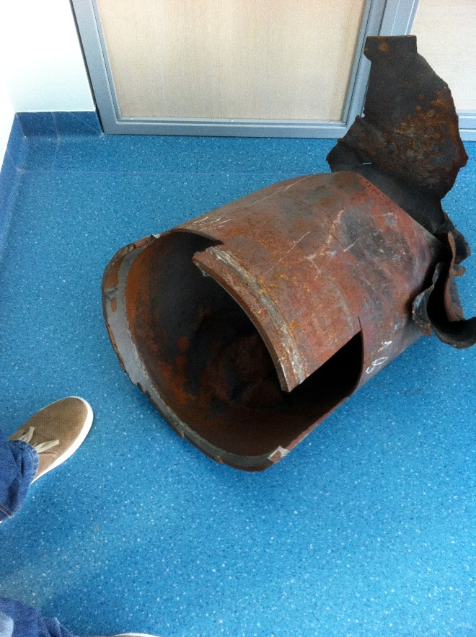
Figure 1<<Figure>>
Caption should explain what the image is and its signficance to the paper, the “what” and the “why”. If the caption needs to question “So what? Why is this image here” if it’s not obvious by showing evidence. More detail an be in the body text. Make graphics full width so we can be assured the resolution is sufficient for publication. Journal will arrange photos as appropriate, to include consolidating captions. EXAMPLE: Figure 1 Photo of the failed carbon steel facility piping. Coupons had been cut out for testing, per OSHA report [3].<<Figure Caption>>

Summary<<Subhead>>
(Summarize the main points that build to the conclusion) The original team had misused the pressure vessel code, which is not intended for failure analysis, and produced a report that would have likely to have been impeached by the court. The third-party team applied appropriate failure analysis procedures, completed the legal team’s other inquiries, including those regarding other potential defects and useful remaining life, and submitted the report of record. The report was part of an overall defense against the prosecution’s case regarding the facility’s published maintenance procedures. The report provided hard numbers to counter the prosecution’s assumptions. The court-appointed experts concurred with the report’s findings, and the defense prevailed.
Conclusion<<Subhead>>
(Answer the thesis, add any broadening comments about signficance, avoid adding new facts or citation). Engineering codes and standards are vital tools for engineers to master. They explicitly evaluate compliance and implicitly provide the reliability associated with the codes and standards when all of the elements of the code methods are met. These standards are part of an overall system to provide the reliable, consistent, and safe application of engineering within the design envelope. [ANSWERS THESIS:] This case illustrates how an investigator must look beyond the traditional role of “design to the code.” The investigator must the underlying theory and assumptions as well as how to apply tools such as the Finite Element Method in order to assess a structure for failure instead of code compliance. [BROADENING STATEMENT/SIGNIFICANCE TO FORENSIC ENGINEERING AND/OR PUBLIC SAFETY] While this case study focuses on ASME pressure vessel codes, the same principles can be applied to other engineering codes and standards. Failing to understand failure theories and properly apply them could result in failing to meet court guidance for expert testimony, such as Federal Rule of Evidence 702, and potentially disqualify the testimony. The methods and principles outline herein can be applied to many other engineering codes and standards.

Acknowledgements<<Subhead>>
List all acknowledgements you would like to include in the article.

References<<Subhead>>
- All references must be cited in the main text in chronological order, not alphabetical.
- The first referenced citation will be number one, the second will be number two, and so forth using brackets: [1], [2-4], [1, 4-6].
- All references must be cited in IEEE style.
- To make things easier, use the Word reference creator to input the sources. Use of a citation manager like ENDNOTE is not required but can be very helpful.
--------------------------------------------------------------------------------------------------------------
Article Template Checklist
- All style names are <<highlighted>> above. You can create your paper in this template by typing over the styles, or you can copy your text from another file and then select the text and choose the style tag for whatever style you want. Click on “Styles” to bring up style box. Highlight the words or section you want and then click on the appropriate style tag.

Please make sure you include all of the elements below:
- Title
- Byline (Name, Post-nominal title, and Member Number)
- Abstract (must be 150 words or less)
- Keywords separated by commas
- Author’s contact information listed in footer of first page
- Subheads (bold headings)
- Paper Body Text (main text). You can use bulleted list or numbered list within main text.
- Body of paper broken up by subheads (no italics or sub subheads)
- All graphics along with Figure # and standalone caption.

- Acknowledgements
- Reference section listed by number in IEEE style

- All Figures must be listed in chronological order (see Figure 1, etc.) in the main body text. You cannot start off with see Figure 9, then jump to Figure 2, then Figure 7, etc.

- All graphics of any kind (photos, tables, graphs) are considered “Figures.” So please name them accordingly. Every item will be Figure 1, Figure 2… no Table 1, Photo 1…
- All figures must have a standalone caption. Please make these descriptive, not just a few words… so that the reader can tell what the image is talking about without necessarily reading the whole paper.
- Figures must be high resolution or as high of resolution as possible (300 dpi as large as you have them).
- You should embed the figures in the Word template so that the reviewers can reference your graphics. However, we need all graphics sent as individual high-res .jpgs to Ellen so that they can be placed in InDesign for the final layout.
- References must be cited in IEEE style. Please use the Reference creator in Word to create your styles and click on IEEE style. A separate tutorial on this will be coming.
- References must be cited in the text in order they appear in the paper in chronological order.

